

CSE 401 Senior Design

Project Report II

Team Members:
Tarık Ziya Aykut - 210402001
Ammar Yasir Bayır - 221401042
Vefa Mert Toker - 221401046
Yusuf Eren Arı - 221401010

Project Customer:
Department of Computer Engineering, Acıbadem University
Prof. Dr. Ahmet Bulut

Introduction
An efficient assessment of student competency in terms of specified Program Outcomes and Course Outcomes requires a reliable, continuously monitoring system. Existing procedures are often manual and result in an inaccurate picture of student performance, preventing necessary intervention and meaningful academic program improvements.
The MVP's primary value is its ability to seamlessly track student performance based on defined learning outcomes. The system provides core functionality designed for four key user roles: Administrator, Lecturer, Student and Guest.

User Stories by Role

Role: Administrator
- Setup & Management
  - As an Admin, I can log in to a secure admin dashboard.
  - As an Admin, I can create, view, update, and delete Programs).
  - As an Admin, I can define high-level Program Outcomes (POs) for each program.
  - As an Admin, I can create Courses and assign them to a Program.
  - As an Admin, I can create Lecturer and Student user accounts and enroll them in their respective courses.

Role: Lecturer
- Course & Assessment Management
  - As a Lecturer, I can log in and see a dashboard of only the courses I teach.
  - As a Lecturer, I can define specific Course Outcomes (COs) for my course.
  - As a Lecturer, I can link my COs to the predefined POs.
  - As a Lecturer, I can create an Assessment and assign it a weight.
  - As a Lecturer, I can map each Assessment to one or more Course Outcomes it evaluates.
- Monitoring & Evaluation
  - As a Lecturer, I can select an Assessment and enter scores for all enrolled students.
  - As a Lecturer, I can view the Student Competency Profile for any student in my course to see their strengths/weaknesses at a glance.
  - As a Lecturer, I can view the Course Heatmap to see how my entire class is performing on each Course Outcome.
Role: Student
- Performance Tracking
  - As a Student, I can log in and see a dashboard of my enrolled courses.
  - As a Student, I can view my scores on all completed assessments.
  - As a Student, I can view my personal Competency Profile (radar chart) to visually track my progress toward mastering the course outcomes.

Role: Guest
- Public Course Exploration
  - As a Guest, I can browse a list of publicly available Programs.
  - As a Guest, I can select a Program and see the list of Courses it contains.
  - As a Guest, I can select a Course and view its public-facing details, such as:
    - The course description.
    - The list of Course Outcomes (COs).
    - The Program Outcomes (POs) that the course supports.
    - The weights or importance of these outcomes in the course's design.

What a Guest Cannot Do
  - A Guest cannot see any student information, scores, or performance data.
  - A Guest cannot see any lecturer-specific dashboards or tools.
  - A Guest cannot access any page that requires a login.

Features "Out of Scope" for MVP
To ensure a focused and achievable initial release, the following features will be planned for future versions:
- Adding functionality that adds different university sign-ups.
- %100 compatibility with mobile devices.
- Integrating spreadsheet functionality to make data input simple for lecturers.
- Automated "Early Warning System" notifications.
- Advanced analytics and multi-year reporting for administrators.

Detailed Technical Design

System Architecture
We will implement a Decoupled Monolithic Architecture. The backend will be a single, robust Django application that exposes a RESTful API. The frontend will be a separate, modern application built in React.
This provides the simplicity of monolithic development for the backend while allowing for a fast, responsive user experience with the React frontend.
The system is being built from the ground up as a Multi-Tenant Application. All universities will share the same application and database, but data will be strictly isolated at the database level using a ForeignKey to an Organization table in all relevant models.

Technology Stack
Component | Technology | Why do we use it?
Backend | Python / Django | Team's existing expertise, rapid development, "batteries-included."
API Layer | Django REST Framework (DRF) | The industry standard for building secure, browseable APIs with Django.
Frontend | React | A powerful, component-based library for building a fast and interactive UI.
Database | PostgreSQL | Recommended for Django. Robust, scalable, and handles complex queries well.
Authentication | JSON Web Tokens (JWT) | A stateless, secure method for authenticating the React with the Django REST Framework backend.

Database Schema (Data Models)
- Organization: Different universities will be stored here, thus enabling multi-tenancy.
- User: Extends the built-in Django User to add a role (Admin, Lecturer, Student) and will connect it to Organization.
- Program: A degree program that is linked to an Organization.
- ProgramOutcome: A high-level goal, linked to a Program.
- Course: A specific course, linked to a Program and a Lecturer. May also define the same course again for different semesters.
- CourseOutcome: A course goal, linked to a Course. Can be linked to ProgramOutcome.
- StudentEnrollment: A table linking a Student to a Course.
- Assessment: An item to be graded, linked to a Course (e.g., Midterm, Final, Project).
- AssessmentOutcome: A through-table linking an Assessment to the CourseOutcomes it measures.
- Score: The final model, linking a StudentEnrollment to an Assessment and storing the score value.
User Experience (UX) & Interface (UI) Flow

Think about a lecturer. The lecturer logs in and lands on their dashboard. They click a Course, which takes them to the course page that shares detailed information about the course. At the top, they see the "big picture", which is a radar grid. They instantly spot an anomaly on the grid , indicating the whole class struggled with "Outcome 3." In the bottom of the radar grid, they can see buttons for each course outcome, which navigates into another radar grid that shows the averages for each assignment. Lecturer can see the scores for midterm are the cause of the anomaly in the averages The lecturer now has a complete, data-backed story to discuss with the class, all in three clicks.
In the MVP, we are planning to properly visualize and monitor the scores of the students, using a variety of graphs and grids that will help the lecturer to analyze the progress and assess the vulnerabilities in the course design.

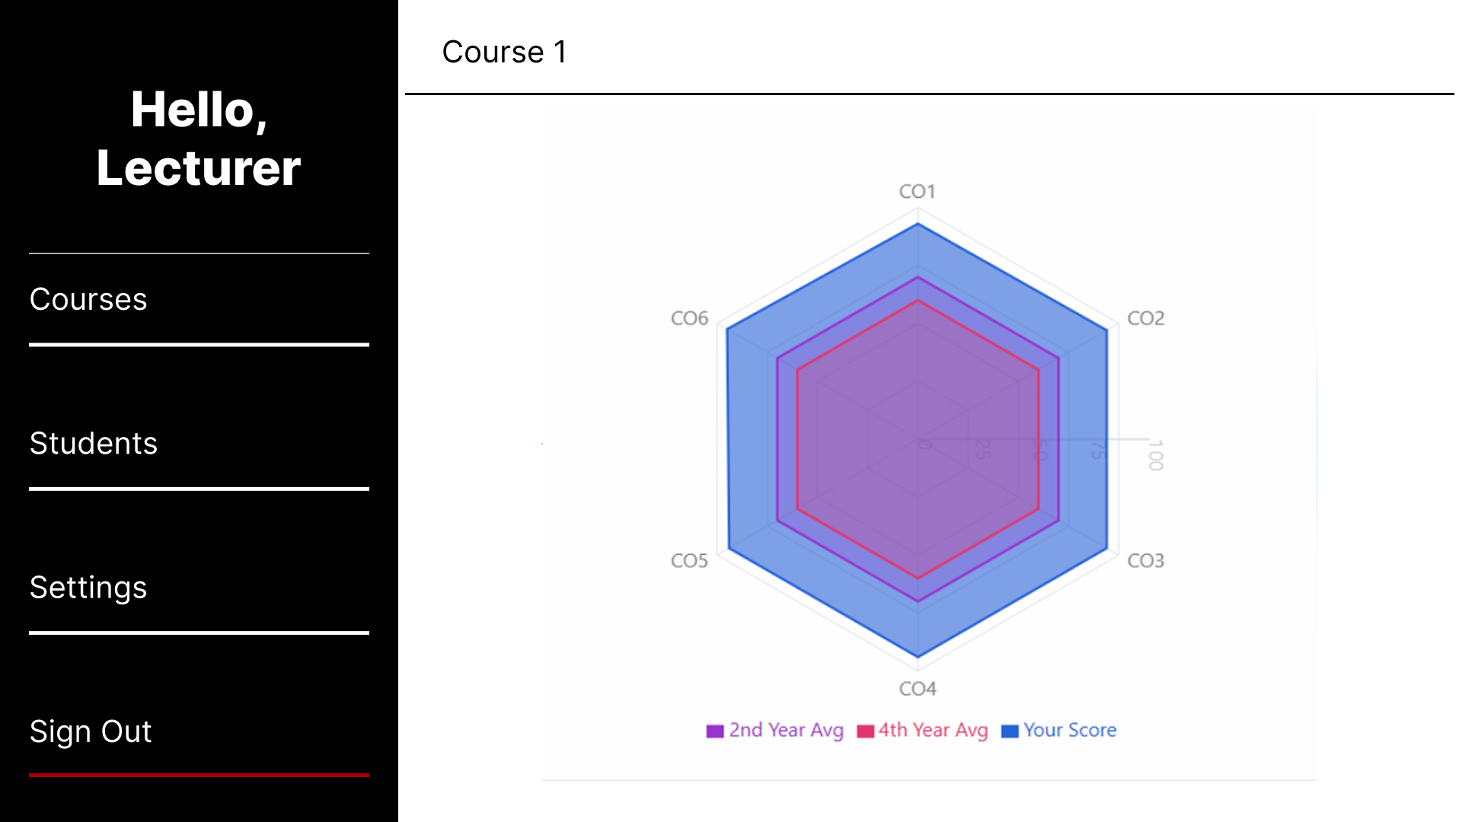

Client Approval

Client Information:
Name: Prof. Dr. Ahmet Bulut
Position: Head of Department
Date:
Signature:

